

*Software Quality Engineering*  
*LabTask 03*

Name : Muhammad Shamoil  
Section : BSSE – V – A  
Submitted To : Sir Naseer Jaan

# Main Program

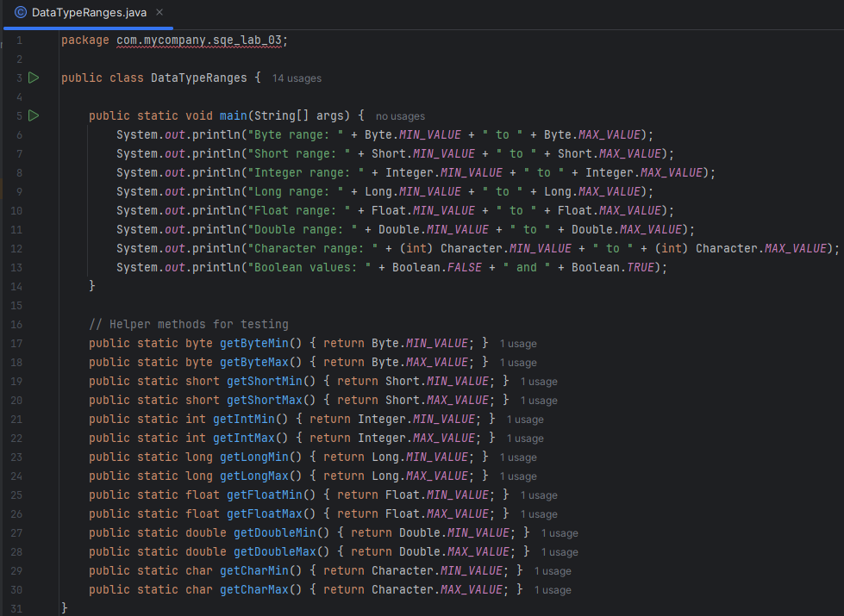

# Program Output:

# Test Program

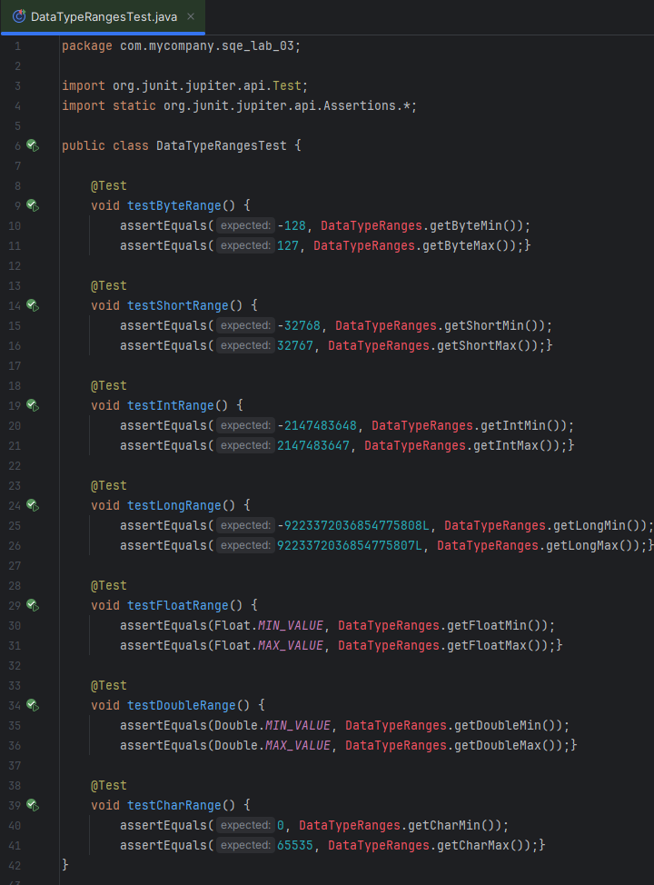

# Testing Results

